Structuring the views in CAPRI by task

Wolfgang Britz, 26.11.2014

Background

By trying to locate a view data generated by COCO respectively CAPREG, I became aware of the fact that we offer many views for exploitation of results (e.g. for “Build regional database”) which are irrelevant or even worse mis-guiding. Often tables only comprise one item, or just data for a handful of products, simply as the definitions relate e.g. to position calculated post-model from a simulation run. Whereas the more experienced CAPRI users are probably aware of which tables makes sense for which task, unexperienced users can get lost and frustrated by e.g. trying out several variants of market balances.

Since a while, the java code which reads the view definitions (so far stored under “gui\tables.xml”) can handle includes. That was the starting points for the refactoring described briefly in the following.

New solution

1. First, in order to cleanse somewhat the “GUI” folder as now more files will be present, all view definitions had been moved to “GUI\views”.
2. Next, the java code was expanded such that a task can have its own view definition file. For CAPREG, to give an example, the following entry can be found:  
   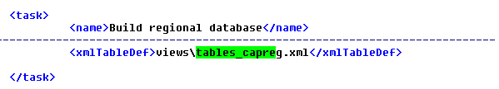
3. The tables from “tables.xml” had been grouped such that they match (hopefully the different tasks / modules. The file above for “CAPREG” looks as follows:

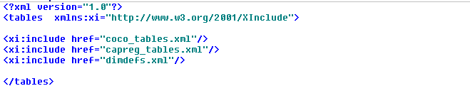

It hence comprises only include statements. It is assumed that all tables which can be inspected with COCO can also be inspected with CAPREG. The “dimdefs.xml” comprises the lists with regions, products, activities etc..

1. All tasks which have not yet their own view definition file use the new “tables_inc.xml” which looks as follows:  
   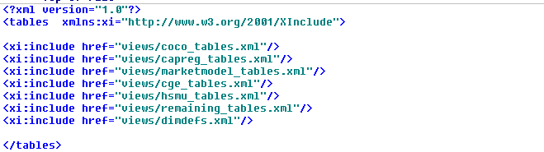

The code was tested, but as always, bugs are possible. Please report back if you encounter something curious.